Ísland Arkitekture 1990 2020-11-24

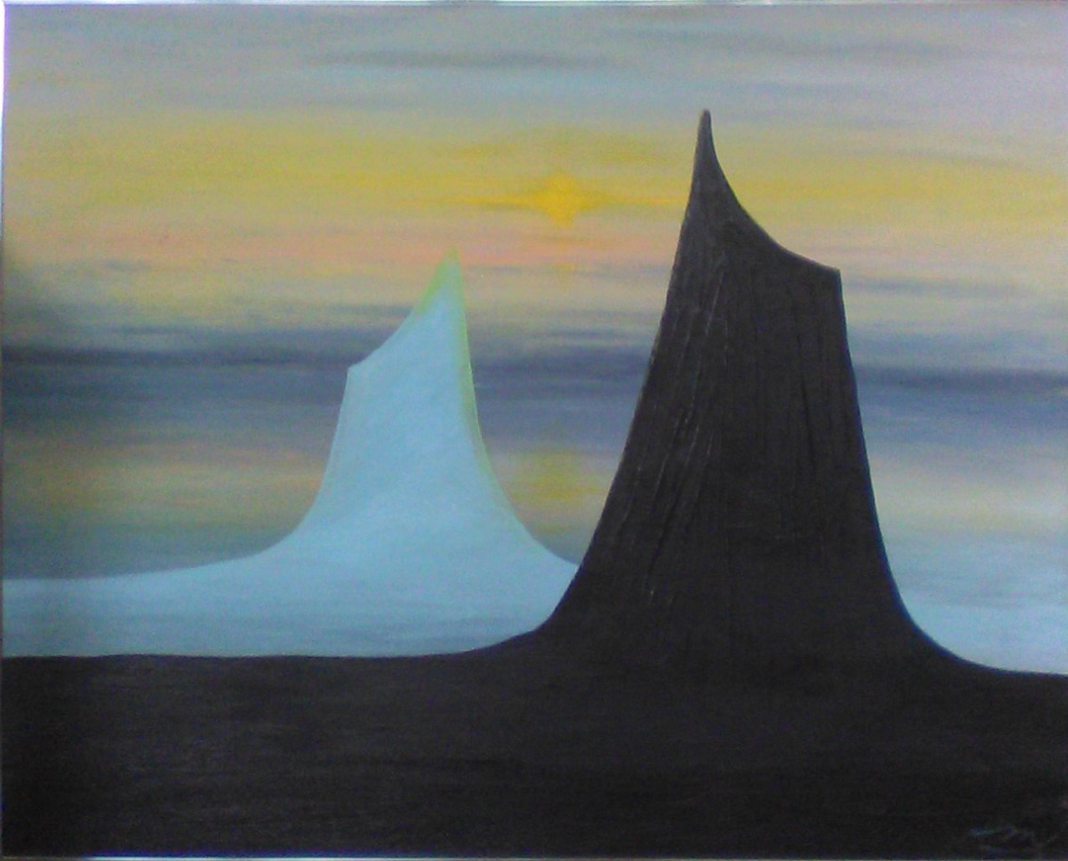

Stone and sea both
sang to me, ‘Here
is our pattern
poetry.

Paint
Parallel, our
story tell ‘neath
soaring sunlit sky.’

